Use-Case Realization Report
Add Lesson

Issue 1.0
Revision History
Date | Issue | Description | Author
01/08/2009 | 1.0 | Add Lesson | Haiyang

Table of Contents
1. Brief Description 4
2. Flow of Events 4
3. Interaction Diagrams 5
3.1 Collaboration Diagram for Add Lesson 5
4. Participating Objects 5
5. Class Diagrams 6
5.1 Class Diagram for Add Lesson 6
6. Derived Requirements 6

Use-Case Realization Report
Add Lesson

Brief Description

Flow of Events

Standard Flow
- Portal Admin log into the system, and go to Lesson Admin Page.
- By clicking the “Add Lesson” button, the JMD module will be called, and the Lesson Page will be displayed.
- JMD module will then process adding the lesson.
- The lesson and the section information will then be stored in Lesson Module, for later reference.
- A message says “Lesson has been successfully added.” will be displayed.

Interaction Diagrams

Collaboration Diagram for Add Lesson
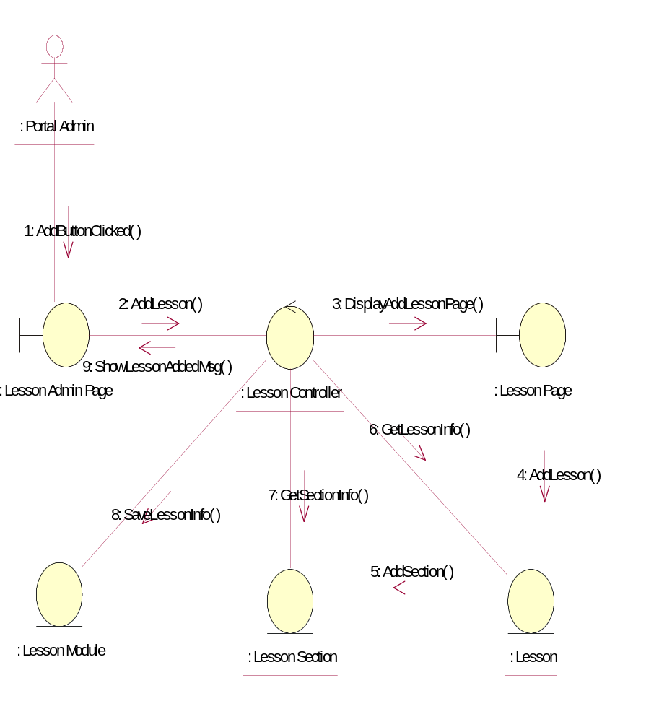

Participating Objects
: Lesson
This entity is the lesson object, it belongs to JMD.
: Lesson Admin Page
This is the page for adding, deleting, modifying lessons.
: Lesson Controller
This is the controller to upload, add, delete and modify lessons.
: Lesson Module
This is the object containing the lesson info.
: Lesson Page
Lesson Page is the one from JMD, which in charge of creating lessons.
: Lesson Section
This entity is the Section object, it belongs to JMD.
: Portal Admin
This is the super user of the system.

Class Diagrams

Class Diagram for Add Lesson
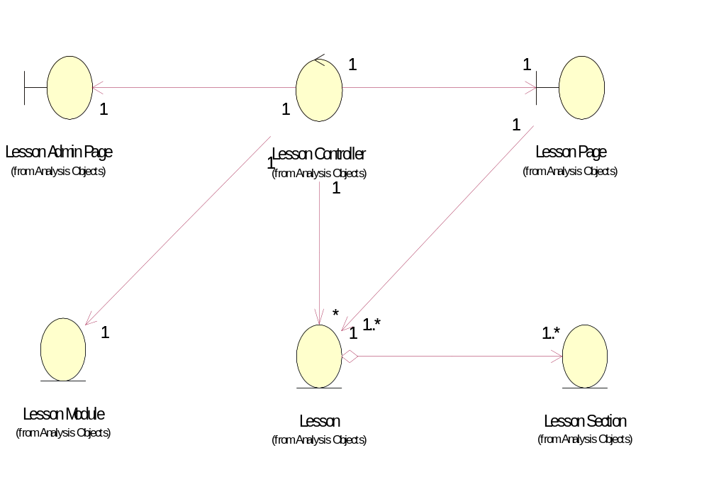

Derived Requirements
[enter the derived requirements here]

